13.28: At the time in question we have
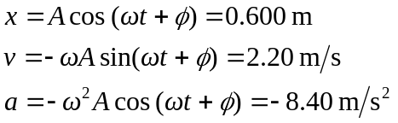

Using the displacement and acceleration equations:
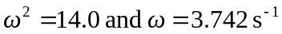 To find A, multiply the velocity equation by
Next square both this new equation and the acceleration equation and add them:
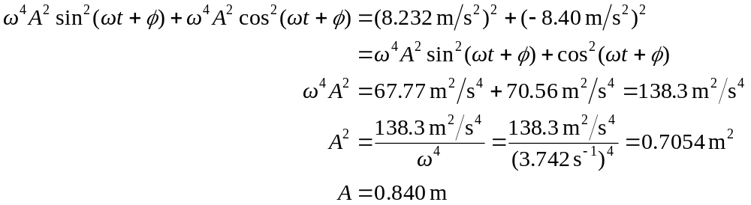

The object will therefore travelto the right before stopping
at its maximum amplitude.

